Period 4 | Period 5
95 | 82
98 | 79
97 | 93
65 | 45
55 | 44
92 | 91
86 | 78
95 | 80
91 | 99
94 | 100
93 | 76
78 | 66
85 | 72
100 | 88
69 | 74
66 | 80
91 | 95
78 | 83
100 | 84
 | 96
 | 100
 | 84
 | 62
In this activity, students create and explore a box and whisker diagram and histogram for a data set. They then compare the two data displays by viewing them together and use the comparison to draw conclusions about the data.

Problem 1 – Period 4 vs. Period 5 Test Results Comparing distributions without graphing.
To the right are results from a recent test. The teacher wants to graphically display this data so the students can get a quick sense for how the class did and how they compare with the other class period. Additional benefits of displaying the data graphically are that the students won’t see individual results and they will refresh their understanding of histograms and box and whisker diagrams.
Enter the test scores for period 4 and 5 data on the STAT, EDIT screen.

- Without graphing the data, describe each data set. To better estimate the center and spread of each data set, sort using S 3:SortD(. Then use ` S to select the list P4. Repeat for P5, period 5.

- If you were to make a histogram, describe an appropriate window. In other words, find the range of the data.

- Explain how wide you would make the bins in the histogram. For example, for a bin width of 10, find how many period 4 and period 5 students there are with test scores of 60 to 69.

Comparing distributions using histograms
Graph each data set using a histogram.  Press ! and clear or turn off any functions that are graphed. Press ` ! for å to open the Stat Plot menu and choose Plot1.  Turn the plot On, choose the histogram icon for the plot type as shown on the right. Use a to enter P4 for the Xlist, or find the list in ` ò.  Press @ to explore the data in the window you chose in question #2, or set it up with the window settings on the right. The Xscl determines the bin width. Press % to see the histogram.  Press $ and the arrow keys to see the contents of each bar.  Press @ and change the Xscl value to adjust the width of the bars of the histogram. Experiment with different Xscl values.  Repeat these steps to graph P5 as a histogram in Plot2.  View the graphs together to compare them. Turn both Plot1 and Plot2 On.  - Explain why it is important for the scales to be the same when comparing the data. | 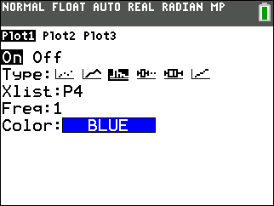  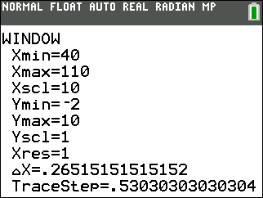  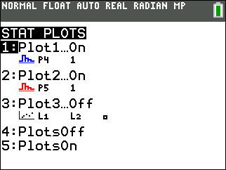
- Compare the two histograms. Explain the shape and spread.

- Estimate the mean and median for each team. Explain which bin you think the mean will be in. Discuss with a classmate if you think the median will be to the left or right of the mean. Explain.

Now compare your estimate of the mean and median to the actual values. Press S, arrow to the right once to select CALC and press e to select one variable statistics. Press ` ò to select P4 for the 4th period. Then arrow down to Calculate and press e. The symbol for mean is . Arrow down to see the median, abbreviated Med. Repeat for P5, 5th period data. | 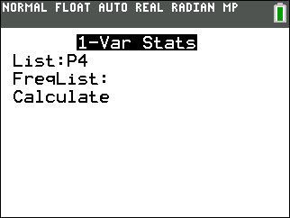
- Record the actual mean and median for both teams and reflect on how your estimation compares.

- Describe what the graphs would look like if the width of the bars is changed. Explore changing the bin width by changing the Xscl in @. Explain what effect this would have.

Comparing distributions using box and whisker diagrams
Sometimes, a box plot is more appropriate or useful to compare two data sets.
Graph each data set using a box and whisker diagram.  Press ` ! to change the å for Plot1 and Plot2 to the first type of box and whisker diagram as shown on the right. Use ZoomStat to view the graph in an appropriate window.  Press $ and the arrow keys to see the minimum, lower quartile, median, upper quartile, and maximum of each box and whisker diagrams. | 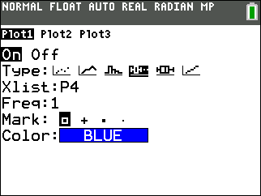
- Find the IQR, interquartile range, for period 4 and 5.

- Explain what the “dots” on period 5’s test score box and whisker diagram indicate.

- Explain why there are outliers for period 5, but not for period 4.

- Explain what you notice about the top 25% of both classes. Compare the two box and whisker diagrams, including shape, spread, and the five-number summary.

- Explain the conclusions you can make about the test scores of the students in period 4 and 5. Each conclusion needs to be supported by a number or a graph.

Further IB Application

Kevin is trying to improve his putting. For the forty rounds of golf he played last year, the number of one putt holes Kevin has in a given 18 hole round of golf was recorded. The data was organized in a box and whisker diagram as shown below.
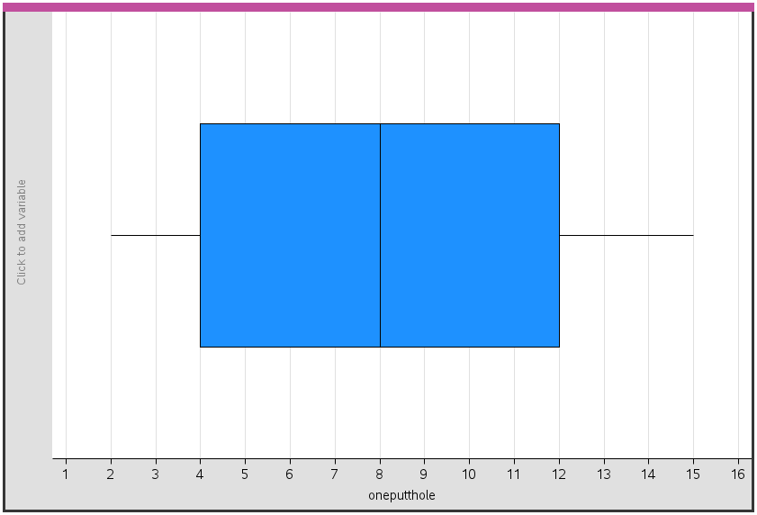

For this data, write down
(a) (i) The minimum number of one putt holes for a round out of the 40 rounds Kevin played last year

(ii) The lower quartile

(iii) The median.

(b) Kevin claims that this box and whisker diagram can be used to infer that the percentage of rounds with 5 one putt holes is smaller than the percentage of rounds with 9 one putt holes. State whether Kevin is correct. Justify your answer.

