Math Objectives  - Students will explore the definition of a bearing and how to represent it in a diagram given written details.  - Students will be asked to use their knowledge of bearings to find distances and angles in several differing scenarios.  - Students will try to make a connection with how to understand these topics in IB Mathematics courses and on their final assessments.  Vocabulary  - Bearings • Supplementary Angles • Clockwise  About the Lesson  - This lesson is aligning with the curriculum of IB Mathematics Applications and Interpretations SL/HL and IB Mathematics Approaches and Analysis SL/HL  - This falls under the IB Mathematics Core Content Topic 3 Geometry and Trigonometry:  3.3: (a) Applications of right and non-right triangle trigonometry,  including Pythagoras.  (b) Angles of elevation and depression, bearings.  (c) Construction of labelled diagrams from written  statements.  As a result, students will:  - Apply this information to real world situations.  Teacher Preparation and Notes.  - This activity is done with the use of the TI-84 family as an aid to the problems.  Activity Materials  - Compatible TI Technologies: TI-84 Plus*, TI-84 Plus Silver Edition*, TI-84 Plus C Silver Edition, TI-84 Plus CE  * with the latest operating system (2.55MP) featuring MathPrintTM _{functionality.} | 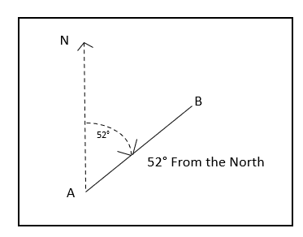  Tech Tips:  - This activity includes screen captures taken from the TI-84 Plus CE. It is also appropriate for use with the rest of the TI-84 Plus family. Slight variations to these directions may be required if using other calculator models.  - Watch for additional Tech Tips throughout the activity for the specific technology you are using.  - Access free tutorials at http://education.ti.com/calculators/pd/US/Online-Learning/Tutorials  Lesson Files:  Student Activity  84CE_CanYouFindYourBearings-Student.pdf  84CE_CanYouFindYourBearings-Student.doc
In this activity, you will review how to find bearings through given descriptions and reading diagrams. You will use your knowledge of trigonometry and angles to apply this topic of bearings to real world situations.
______________________________________________________________________________
Let’s review what a bearing is. In mathematics, a bearing is the angle in degrees measured clockwise from the north. Bearings are usually given as a three-figure bearing. For example, 30° clockwise from the north is usually written as 030°. Bearings are commonly used when traveling by plane, boat, or just navigating a hike.

During this activity, you will be using some or all of the formulas from your trigonometry lessons.

Pythagorean Theorem: $a^{2}+ b^{2}= c^{2}$ $\sin{θ}= \frac{opp}{hyp}$ $\cos{θ}= \frac{adj}{hyp}$ $\tan{θ}= \frac{opp}{adj}$

Sine Rule: $\frac{a}{\sin{A}}= \frac{b}{\sin{B}}= \frac{c}{\sin{C}}$ Cosine Rule: $a^{2}= b^{2}+ c^{2}-2bc∙\cos{A}$ $d=r∙t$

Teacher Tip: Depending on how and what you have taught up to this point, there will be multiple ways to answer the following questions. The teacher notes focus on using the sine rule, cosine rule, and distance formulas from above, but there may be alternate methods.

Tech Tip: Before you start this activity, it might be wise to discuss rounding and significant figures with your students. Showing them how to change the number of digits shown in a calculator response would really help them as they progress through mathematics and science courses.

Problem 1 – The Art of Drawing a Given Bearing

1. Alex is hiking up and around Paris Mountain in Greenville, South Carolina. After leaving the visitor’s center, she plans to head up the mountain on a bearing of 067°. Draw that bearing below.
N

Solution: 67°

_{Visitor’s Center}

2. Amanda was going to hike with Alex, but changed her mind once she left the visitor’s center. She decides to go up the mountain on a bearing of 283°. Draw that bearing below.
N

Solution: 283°

_{Visitor’s Center}

3. Cameron is flying from Los Angeles to Dallas, but he has to change planes in Colorado Springs. The bearing from LA to Colorado Springs is 075° and the bearing from Colorado Springs to Dallas is 132°. Draw this flight path with the given bearings below.

Solution:
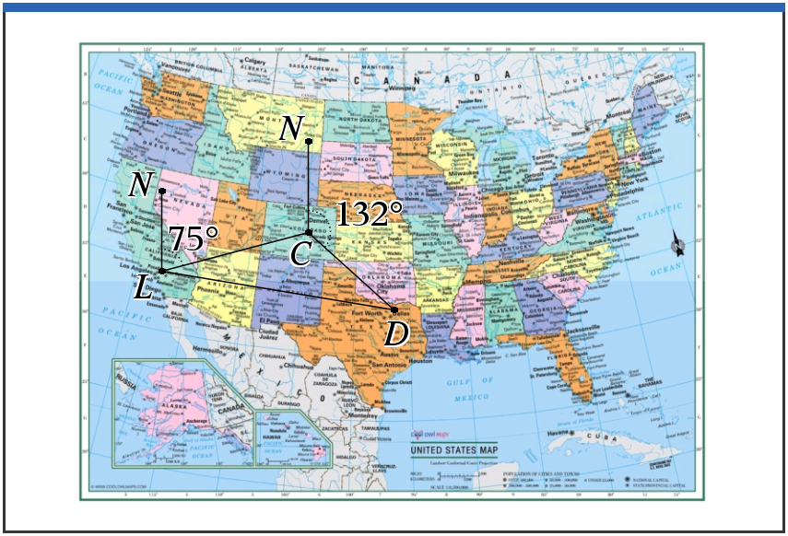

Problem 2 – Using Bearings to find Distances

1. Using the information from Problem 1, Cameron is flying from Los Angeles to Dallas, but he has to change planes in Colorado Springs. The bearing from LA to Colorado Springs is 075° and the bearing from Colorado Springs to Dallas is 132°. If the distance from LA to Colorado Springs is 1742 km, and the distance from Colorado Springs to Dallas is 1173 km, find the distance of a direct flight from LA to Dallas in kilometers.

Solution: Using the diagram from problem 1, question 3, you are finding the length of LD. Knowing
that the length of LC is 1742 km and the length of CD is 1173 km, you will need to find $L\hat{C}D$ to have
a side-angle-side scenario and use the Cosine Rule. To find $L\hat{C}D$, you will need to remember that
consecutive angles of a quadrilateral are supplementary to find the exterior angle at C that is not
132°. Then knowing that the three angles at C have a sum total of 360° you can find the interior
angle at C.

$180°-75°=105°$
$360°-132°-105°=123° (interior angle at C)$
Cosine Rule: ${\left(LD\right)}^{2}= {1742}^{2}+ {1173}^{2}-2∙1742∙1173∙\cos{123°}$
$LD= \sqrt{{1742}^{2}+ {1173}^{2}-2∙1742∙1173∙\cos{123°}}$
$LD ≈2576.099… or 2576 km$

2. Find the bearing for this direct flight to Dallas from LA.

Solution: Find $C\hat{L}D$ first: Sine Rule $\frac{2576}{\sin{123°}}= \frac{1173}{\sin{C\hat{L}D}}$ Cosine Rule $\cos{C\hat{L}D}= \frac{{1742}^{2}+ {2576}^{2}- {1173}^{2}}{2∙1742∙2576}$
$\sin^{-1}\left(\frac{1173∙\sin{123°}}{2576}\right)$ $C\hat{L}D ≈22.5°$
$C\hat{L}D ≈22.5°$
Add this answer to the given bearing from LA to Colorado Springs.
75 + 22.5 = 97.5
Bearing to Dallas from LA is $098°$

3. Reed leaves on his boat from the port at Hilton Head Island, SC and travels on a bearing of 059° toward Fripp Island. If he travels at a speed of 34 km per hour and arrives 45 minutes later, draw the bearing below and find the distance that he travelled from Hilton Head to Fripp.

Solution:
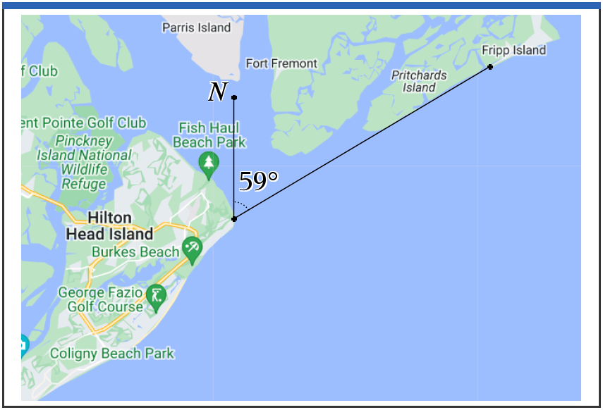

$d=r ∙t$
$d=\left(34\right)\left(0.75\right)=25.5 km$

Problem 3 – Bringing it All Together

1. Percy is trying to get to his camp from his broken down car. His car is represented by point A and his camp is represented by point C in the diagrams below. He hikes at an average speed of 3.8 km/h for 50 minutes, on a bearing of 040° from the car, until he stops for a break at point B, where there is a shelter for hikers. Find the distance from point A to point B. N B

Solution: $AB= \frac{3.8}{60} ×50=3.17 km$
Diagrams not to scale

A

2. Percy leaves the shelter on a bearing of 105° and continues to hike for a distance of 4.2 km until he reaches the camp. Show that angle $A\hat{B}C$ is 115°. N
N B 105°
Solution: 75° or (180° - 105°) _{75°}
Diagrams not to scale 40° + 75° = 115° 40° ^{40°}
C

A
3. Find the distance from the broken down car to the camp at point C.

Solution: ${AC}^{2}= {3.17}^{2}+ {4.2}^{2}-2∙3.17∙4.2∙\cos{115°}$
$AC=6.24 km$

4. Find $B\hat{C}A$.

Solution: Sine rule $\frac{3.17}{\sin{B\hat{C}A}}= \frac{6.24}{\sin{115°}}$ Cosine rule $\cos{B\hat{C}A}= \frac{{4.2}^{2}+ {6.24}^{2}- {3.17}^{2}}{2∙4.2∙6.24}$
$B\hat{C}A=27.4°$ $B\hat{C}A=27.4°$

5. Percy’s friend Annabeth, who was waiting in the car for the tow truck to arrive, wants to hike directly to the camp at point C. Find the bearing that Annabeth must take to point C.

Solution: $B\hat{A}C=180°-27.5°-115°=37.5°$
Bearing = $37.5°+40°=77.5° (accept 078°)$

6. Annabeth hikes at an average speed of 4.1 km/h. Find, to the nearest minute, the time it takes for Annabeth to reach point C.

Solution: $t= \frac{d}{r}= \frac{6.24}{4.1/60}= 91.317 ≈91 minutes$

Further IB Application

The towns of Chesternut (C), Traitsville (T), and Berkston (B) are represented in the following diagram. Chesternut lies 450 km directly east of Traitsville, and $\hat{TC}B=29°$.
N
B Not to scale.

_{29°}
T 450 km C

The bearing of B from T is 054°.
(a) Find $T\hat{B}C$.
Solution: $B\hat{T}C=90°-54°=36°$
$T\hat{B}C=180°-29°-36°=115°$

(b) Find the distance between Chesternut and Berkston.

Solution: Sine rule $\frac{450}{\sin{115°}}= \frac{CB}{\sin{36°}}$
$CB=291.847 ≈292 km$

Teacher Tip: It may be helpful for students to discuss the alternate ways to write a bearing. In this activity 30° from the north is written as 030°. Another way to write this is to use the North, South, East and West notations, eg. 30° from the north can be written as N 30° E. This allows for multiple variations for each bearing and it may make your students understanding clearer.

**Note: This activity has been developed independently by Texas Instruments and aligned with the IB Mathematics curriculum, but is not endorsed by IB™. IB is a registered trademark owned by the International Baccalaureate Organization.

