In this activity, you will review how to find bearings through given descriptions and reading diagrams. You will use your knowledge of trigonometry and angles to apply this topic of bearings to real world situations. | 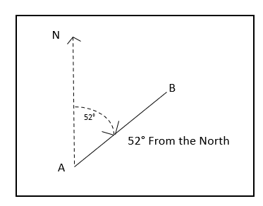
_____________________________________________________________________________________
Let’s review what a bearing is. In mathematics, a bearing is the angle in degrees measured clockwise from the north. Bearings are usually given as a three-figure bearing. For example, 30° clockwise from the north is usually written as 030°. Bearings are commonly used when traveling by plane, boat, or just navigating a hike.

During this activity, you will be using some or all of the formulas from your trigonometry lessons.

Pythagorean Theorem: $a^{2}+ b^{2}= c^{2}$ $\sin{θ}= \frac{opp}{hyp}$ $\cos{θ}= \frac{adj}{hyp}$ $\tan{θ}= \frac{opp}{adj}$

Sine Rule: $\frac{a}{\sin{A}}= \frac{b}{\sin{B}}= \frac{c}{\sin{C}}$ Cosine Rule: $a^{2}= b^{2}+ c^{2}-2bc∙\cos{A}$ $d=r∙t$

Problem 1 – The Art of Drawing a Given Bearing

1. Alex is hiking up and around Paris Mountain in Greenville, South Carolina. After leaving the visitor’s center, she plans to head up the mountain on a bearing of 067°. Draw that bearing below.

N

_{Visitor’s Center}

2. Amanda was going to hike with Alex, but changed her mind once she left the visitor’s center. She decides to go up the mountain on a bearing of 283°. Draw that bearing below.

N

_{Visitor’s Center}

3. Cameron is flying from Los Angeles to Dallas, but he has to change planes in Colorado Springs. The bearing from LA to Colorado Springs is 075° and the bearing from Colorado Springs to Dallas is 132°. Draw this flight path with the given bearings below.

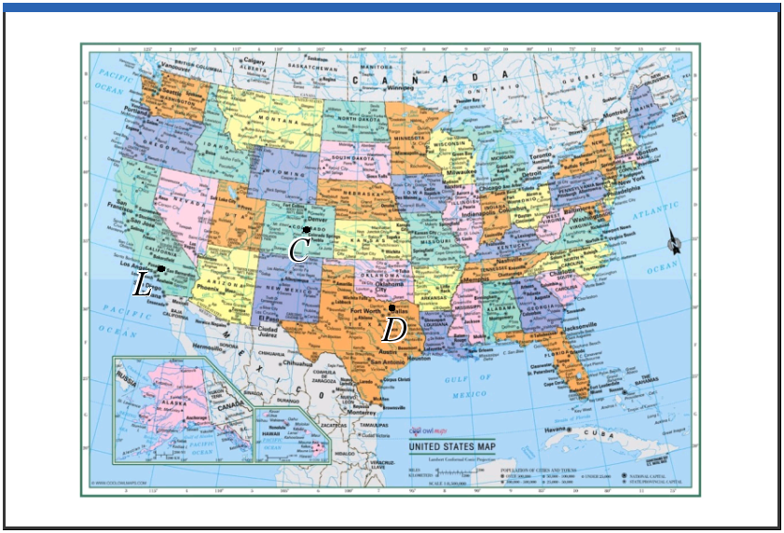

Problem 2 – Using Bearings to find Distances

1. Using the information from Problem 1, Cameron is flying from Los Angeles to Dallas, but he has to change planes in Colorado Springs. The bearing from LA to Colorado Springs is 075° and the bearing from Colorado Springs to Dallas is 132°. If the distance from LA to Colorado Springs is 1742 km, and the distance from Colorado Springs to Dallas is 1173 km, find the distance of a direct flight from LA to Dallas in kilometers.

2. Find the bearing for this direct flight to Dallas from LA.

3. Reed leaves on his boat from the port at Hilton Head Island, SC and travels on a bearing of 059° toward Fripp Island. If he travels at a speed of 34 km per hour and arrives 45 minutes later, draw the bearing below and find the distance that he travelled from Hilton Head to Fripp.
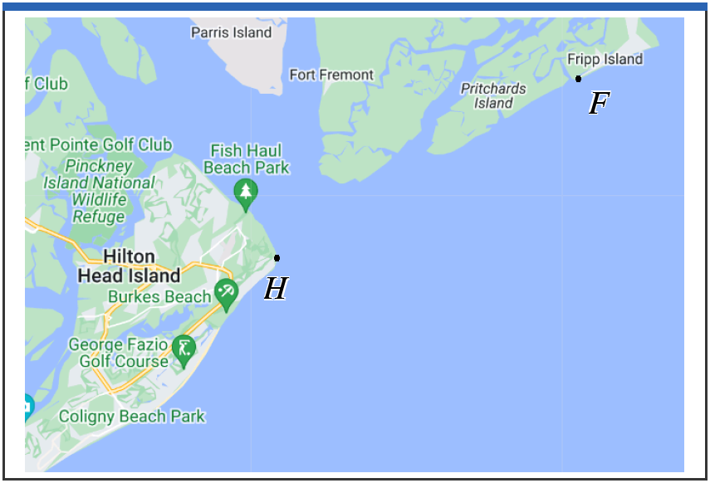

Problem 3 – Bringing it All Together

1. Percy is trying to get to his camp from his broken down car. His car is represented by point A and his camp is represented by point C in the diagrams below. He hikes at an average speed of 3.8 km/h for 50 minutes, on a bearing of 040° from the car, until he stops for a break at point B, where there is a shelter for hikers. Find the distance from point A to point B. N B

Diagrams not to scale

A

2. Percy leaves the shelter on a bearing of 105° and continues to hike for a distance of 4.2 km until he reaches the camp. Show that angle $A\hat{B}C$ is 115°. N
N B

Diagrams not to scale
C

A

3. Find the distance from the broken down car to the camp at point C.

4. Find $B\hat{C}A$.

5. Percy’s friend Annabeth, who was waiting in the car for the tow truck to arrive, wants to hike directly to the camp at point C. Find the bearing that Annabeth must take to point C.

6. Annabeth hikes at an average speed of 4.1 km/h. Find, to the nearest minute, the time it takes for Annabeth to reach point C.

Further IB Application

The towns of Chesternut (C), Traitsville (T), and Berkston (B) are represented in the following diagram. Chesternut lies 450 km directly east of Traitsville, and $\hat{TC}B=29°$.
N
B Not to scale.

_{29°}
T 450 km C

The bearing of B from T is 054°.
(a) Find $T\hat{B}C$.

(b) Find the distance between Chesternut and Berkston.

