Math Objectives  - Students will use their knowledge of patterns to aid in the expansion of binomials, by way of Pascal’s triangle.  - Students will use the Binomial Theorem to discover specific terms of a binomial expansion.  - Students will try to make a connection with how to understand these topics in IB Mathematics courses and on their final assessments.  Vocabulary  - Expansion • Combinations • Pascal’s Triangle  - Coefficient  About the Lesson  - This lesson is aligning with the curriculum of IB Mathematics Approaches and Analysis SL/HL  - This falls under the IB Mathematics Content Topic 1 Numbers and Algebra:  AA 1.9: (a) The Binomial Theorem, expansion of ${\left(a+b\right)}^{n}, n ∈ N$  (b) Use of Pascal’s triangle and $_{n}C_{r}$  As a result, students will:  - Apply this information to real world situations.  TI-Nspire™ Navigator™  - Transfer a File.  - Use Class Capture to examine patterns that emerge.  - Use Live Presenter to demonstrate.  - Use Teacher Edition computer software to review student documents.  - Use Quick Poll to assess students’ understanding.  Activity Materials  Compatible TI Technologies:  TI-Nspire™ CX Handhelds, TI-Nspire™ Apps for iPad®,  TI-Nspire™ Software | 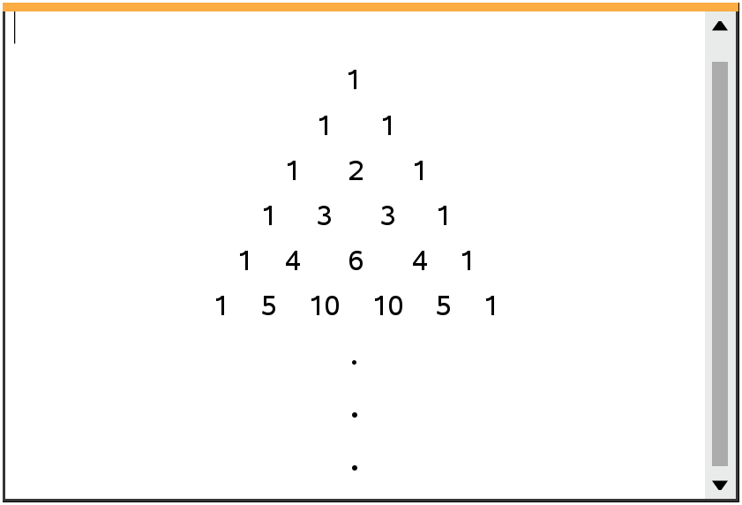  Tech Tips:  - This activity includes screen captures taken from the TI-Nspire CX II handheld. It is also appropriate for use with the TI-Nspire family of products including TI-Nspire software and TI-Nspire App. Slight variations to these directions may be required if using other technologies besides the handheld.  - Watch for additional Tech Tips throughout the activity for the specific technology you are using.  - Access free tutorials at http://education.ti.com/calculators/pd/US/Online-Learning/Tutorials  Lesson Files:  Student Activity  Nspire-BinomialExpansion-Student.pdf  Nspire-BinomialExpansion-Student.doc

In this activity, students will review their binomial expansion skills through hands on multiplication combined with the handheld to check their work. Close attention will be played to individual terms of certain expansions throughout the activity. The Binomial Theorem and Pascal’s Triangle will also be used as tools to aid in this process. | 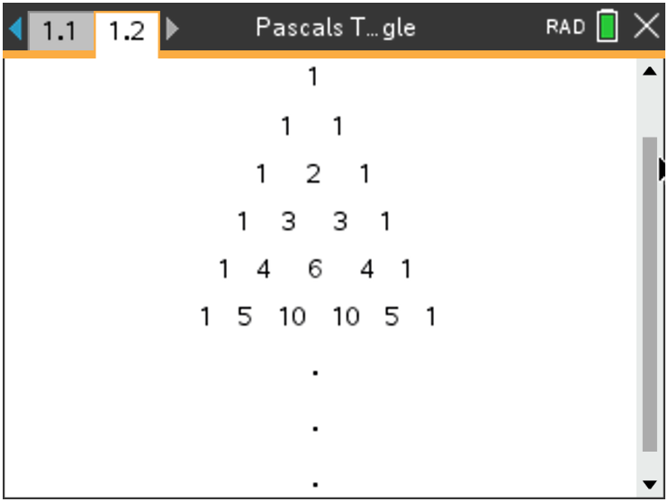
______________________________________________________________________________

What is binomial expansion? It is a method used that allows us to expand and simplify algebraic expressions in the form ${\left(a+b\right)}^{n}$, into the sum of one or more terms, where $n ∈ N$. For example:

$${\left(a+b\right)}^{3}= a^{3}+3a^{2}b+3ab^{2}+b^{3}$$

There are several ways to approach this expansion, those of which we will discuss throughout this activity. In addition to finding an entire expansion, we will find and use individual terms within certain expansions.

Problem 1 – The Basic Expansion

1. If the expansion of ${\left(a+b\right)}^{4}= a^{4}+4a^{3}b+6a^{2}b^{2}+4ab^{3}+ b^{4}$, discuss with a classmate at least two methods you would use to find this expansion. Write those methods here.

Possible Methods: Pascal’s triangle, Binomial Theorem, multiplying $(a+b)(a+b)(a+b)(a+b)$

2. Discuss with a classmate any patterns you noticed from the expansion given in question 1. Write those patterns here.

Possible Patterns: -The number of terms in the expansion is one more than the degree
-The a-exponent decreases by 1 each term from left to right (descending order)
-The b-exponent increases by 1 each term from left to right (ascending order)
-The sum total exponents for each individual term is equal to the degree

3. Using the patterns and methods discussed in questions 1 and 2, find the expansion of ${\left(a+b\right)}^{5}$.

Solution: ${\left(a+b\right)}^{5}= a^{5}+ {5a}^{4}b+ {10a}^{3}b^{2}+ {10a}^{2}b^{3}+ {5ab}^{4}+ b^{5}$

Problem 2 – Beyond the Basic Expansion

1. Discuss with a classmate what would change about your procedure from problem 1 if you were trying to find the expansion of ${\left(x+3\right)}^{3}$. Explain.

Possible Discussion: In the expansion template of ${\left(a+b\right)}^{3}= a^{3}+ {3a}^{2}b+ {3ab}^{2}+ b^{3}$, you would replace each a in the expansion with an x and each b in the expansion with the 3, and simplify.

2. Find the expansion of ${\left(x+3\right)}^{3}$.

Solution: ${\left(a+b\right)}^{3}= a^{3}+ {3a}^{2}b+ {3ab}^{2}+ b^{3}$
${\left(x+3\right)}^{3}= {\left(x\right)}^{3}+3{\left(x\right)}^{2}\left(3\right)+3\left(x\right){\left(3\right)}^{2}+ {\left(3\right)}^{3}$
$= x^{3}+9x^{2}+27x+27$

3. Discuss with a classmate what would change about your procedure from problem 1 if you were trying to find the expansion of ${\left(x-y\right)}^{4}$. Explain.

Solution: The expansion would be the same except there is a new pattern, the signs alternate
like this: +, -, +, -, +, …

4. Find the expansion of ${\left(a-b\right)}^{4}$.

Solution: ${\left(a-b\right)}^{4}= a^{4}- {4a}^{3}b+ {6a}^{2}b^{2}- {4ab}^{3}+ b^{4}$

5. Discuss with a classmate what would change about your procedure from problem 1 if you were trying to find the expansion of ${\left(2x+3y\right)}^{3}.$ Explain.

Possible Discussion: Using the expansion template for ${\left(a+b\right)}^{3}= a^{3}+ {3a}^{2}b+3{ab}^{2}+ b^{3}$, replace each a with a (2x) and each b with a (3y), and simplify.

6. Find the expansion of ${\left(2x+3y\right)}^{3}$.

Solution: ${\left(a+b\right)}^{3}= a^{3}+ {3a}^{2}b+3{ab}^{2}+ b^{3}$
${\left(2x+3y\right)}^{3}= {(2x)}^{3}+ {3\left(2x\right)}^{2}(3y)+3{(2x)(3y)}^{2}+ {(3y)}^{3}$
$= {8x}^{3}+ {36x}^{2}y+54{xy}^{2}+ {27y}^{3}$

Teacher Tip: It is important for the students to remember that when they are substituting anything in the ${\left(a+b\right)}^{n}$ template, like 2x or 3y, that they bring the exponent to both the variable and the coefficient.

Problem 3 – The Binomial Theorem

At times, it is unrealistic and time consuming to find the entire expansion. For example ${\left(x+y \right)}^{21}$ would take a class period to expand. This is where the binomial theorem comes into play. The binomial theorem allows you to find individual terms of an expansion. One of the ways that was hopefully discussed in Problem 1, was the use of Pascal’s Triangle. This triangular pattern of data displays each coefficient of any binomial expansion, no matter the degree of the binomial. Each row represents a new expansion, but this too can be time consuming. The binomial theorem uses the idea of combinations to help find these coefficients. The formula used to find individual terms in the binomial theorem is

$$_{n}C_{r} ∙ a^{n-r}∙b^{r}, where n=degree and r=one less than the term number and _{n}C_{r}= \frac{n!}{r!\left(n-r\right)!}$$

Let’s look at an example. If we were given the binomial ${\left(x+y\right)}^{6}$ and we wanted to find the 5th term of the expansion, here is what you would do:
$n=6 and r=4$, therefore $_{6}C_{4}∙ x^{6-4}∙y^{4}=15x^{2}y^{4}$

If you were to expand Pascal’s Triangle to the 6th degree row it would be:
1 6 15 20 15 6 1

Counting from left to right, the 5th term coefficient is 15, the same as the coefficient from the binomial theorem. Please note that the $r$ value is also the y exponent in this term.

Tech Tip: Remind students where to find a combination on the handheld. On a Calculator page, press menu, 5 Probability, 3 Combination and enter C(n, r).

1. Consider the binomial expansion ${\left(x-2\right)}^{8}= x^{8}+ax^{7}+bx^{6}-448x^{5}+…+256$, where $x ≠0$ and $a, b ∈ Z^{+}$
(a) Show that $b= 112$.

Solution: $n=8 and r=2$
$_{8}C_{2} ∙ x^{6}∙{\left(-2\right)}^{2}=28x^{6}\left(4\right)=112x^{6}$
Therefore $b=112$

(b) The coefficient of the 6th term is the opposite of the coefficient of the 7th term. Find these two coefficients.

Solution: $n=8 and r=5$
$_{8}C_{5} ∙ x^{3}∙{\left(-2\right)}^{5}=56x^{3}\left(-32\right)= -1792x^{3}$
Therefore the opposite coefficients are $-1792 and 1792$

2. In the expansion of ${\left(x+p\right)}^{9}$, where $p ∈ R$, the coefficient of the term in $x^{7}$ is 576. Find the possible values of $p$.

Solution: $n=9 and r=2$
$_{9}C_{2} ∙ x^{7}∙{\left(p\right)}^{2}=576x^{7}$
$36x^{7}p^{2}=576x^{7}$
$p^{2}=16$
$p= ±4$

3. Consider the expansion of ${\left({2x}^{2}+ \frac{m}{x}\right)}^{5}$, where $m>0$. The coefficient of the term in $x^{4}$ is $2880$. Find the value of $m$.

Solution: $n=5$ and since we will be dividing by x in the second term of the binomial, care
must be taken to figure out the r value. If you use the $a^{3}b^{2}$ term it will create the fraction
$\frac{{\left(x^{2}\right)}^{3}}{x^{2}}= \frac{x^{6}}{x^{2}}= x^{4}$, therefore r = 2.
$_{5}C_{2} ∙ {({2x}^{2})}^{3}∙{\left(\frac{m}{x}\right)}^{2}=2880x^{4}$
$10 ∙ \left({8x}^{6}\right)\left(\frac{m^{2}}{x^{2}}\right)=2880x^{4}$
$80x^{4}m^{2}=2880x^{4}$
$m^{2}=36$
$m= ± 6$
Since this binomial is the sum of two terms, only the positive answer will work,
Therefore $m=6.$

4. In the expansion of ${\left(5+ x^{2}\right)}^{n+1}$, where $n ∈ Z^{+}$. Given that the coefficient of $x^{6}$ is $1,312,000$, find the value of $n$.

Solution: $1,312,500x^{6}= _{n+1}C_{3} {∙\left(5\right)}^{n+1-3}{\left(x^{2}\right)}^{3}$
$1,312,500x^{6}= _{n+1}C_{3} {∙\left(5\right)}^{n-2}\left(x^{6}\right)$
$1,312,500x^{6}= \frac{n\left(n+1\right)\left(n-1\right)}{6} ∙5^{n-2}∙x^{6}$
Solve this equation using the handheld: $1,312,500= \frac{n\left(n+1\right)\left(n-1\right)}{6} ∙5^{n-2}$
$n=8$

Tech Tip: To solve the equation in the previous question, students may want to work together or receive guidance to do so. If using the CAS handheld, they can use the solve feature or if not they can graph the left hand side and right hand side of the equations and find the intersection.

Further IB Application

Consider the expansion of $\frac{{\left(b∙x-3\right)}^{12}}{15x^{3}}$, where $b≠0$. The coefficient of the term in $x^{8}$ is $-\frac{12}{5}b^{10}$. Find the value of $b$.

Solution: $n=12 and r=1$
$\frac{ _{12}C_{1}{\left(bx\right)}^{11}{\left(-3\right)}^{1}}{15x^{3}}= \frac{-12}{5}b^{10}$
$\frac{12b^{11}x^{11}(-3)}{15x^{3}}= \frac{-12}{5}b^{10}$
$\frac{-36b^{11}x^{8}}{15}= \frac{-12}{5}b^{10}$
$\frac{-12bx^{8}}{5}= \frac{-12}{5}$
$b=1$

Teacher Tip: Throughout this activity, the students are asked to discuss with classmates and explain how they achieved their answers. This is a wonderful opportunity to create a student led classroom. As you float around the room, listen to what they are saying, add to their discussions, and give them leading questions to see how they respond.

Teacher Tip: If students struggle with the understanding of the connection between Pascal’s triangle, binomial expansion, and the Binomial Theorem, you can provide them with this example. Let’s say there are two candy pars on a table and you are asked to choose up to 2 of the candy bars (M and S). What are the number of possibilities of choosing up to 2 of those candy bars? Well, you can choose zero bars, one bar or two bars. There is only 1 possibility of choosing zero or two bars and 2 possibilities of choosing one bar.
Zero bars One bar Two bars
1 2 1
(none) (M or S) (Both M and S)

What if we added a third bar (R) and chose up to three bars?
Zero bars One bar Two bars Three bars
1 3 3 1
(none) (M or S or R) (MS or MR or SR) (All MSR)

Can you visualize the pattern forming (Pascal’s Triangle)? That is why in the Binomial Theorem we use combinations. A combination is a technique that determines the number of possible arrangements in a collection of items where the order of the selection does not matter, in this case, the order of the candy pars.

TI-Nspire Navigator Opportunity: Quick Poll (Open Response)
Any part to any Problem in the activity would be a great way to quickly assess your student’s understanding of finding and discussing both forms of Scientific Notation and Expanded Form.

**Note: This activity has been developed independently by Texas Instruments and aligned with the IB Mathematics curriculum, but is not endorsed by IB™. IB is a registered trademark owned by the International Baccalaureate Organization.

